EMCH 290
Mechanical Engineering Thermodynamics

Homework # 1
Points Possible: 30
Jacob Vaught (9/8/2021)

Problem No. 1 (10 points)
An object whose weight is 100 lbf experiences a decrease in kinetic energy of 500 ft-lbf and an increase in potential energy of 1,500 ft-lbf. The initial velocity and elevation of the object, each relative to the surface of the earth, are 40 ft/s and 30 ft, respectively. If g=32.2 ft/s2, determine:
$$V_{0}={40ft}/s$$
$$H_{0}=30 ft$$
$$Weight=100lb$$
$$ΔKE=-500ft-lbf$$
$$ΔPE=1,500ft-lbf$$
$$KE=\frac{1}{2}*m*v^{2}$$
$$PE=m*g*h$$
- The final velocity, in ft/s.
$$-500=\frac{1}{2}*\frac{100lb}{32.2ft/s^{2}}*{(v^{2}-40}^{2})→v=35.749ft/s$$
- The final elevation, in ft.
$$1500=100lbf*\left(H_{1}-30ft\right)→H_{1}=45ft$$

Problem No. 2 (10 points)
Find the mass flow rate (in gram) of water for a control volume system, if the volume flow rate is 2 litter per second.

Volume flow rate = 2 (liter/s)
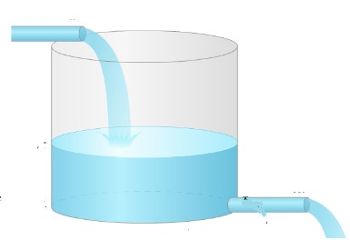
Mass flow rate =? (g)
Control Volume

Water density assumed to be $1g/cm^{3}$
$$1 liter = 1000cm^{3}$$
$$2\frac{liters}{second}*\frac{1000cm^{3}}{liter}=\frac{2000cm^{3}}{second}*\frac{1g}{cm^{3}}→\frac{2000g}{second}$$

Problem No. 3 (10 points)
What is the change in the internal energy of the system if the surrounding releases 300 J of heat energy and if the system does 550 J of work on the surroundings?
Formula:
Δ U = Q + w
Q = + endo W = + on the system
Q = - exo W= - by the system

550 J exothermic and 300 J “on the system”
$ΔU=$300-550= -250 Joules, Loses energy

